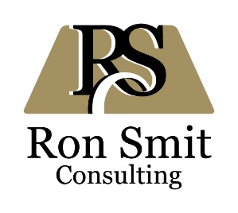
PROFILE

Ron Smit Consulting provides services related to mining sector governance and mining sector development, largely in support of public sector institutions. The owner, Ronald Smit, is a professional natural scientist (Pr.Sci.Nat.) with qualifications in geology (BSc Hons), mineral economics (MSc (Eng)(Mining)) and business administration (MBA). He has more than 30 years of experience in the mining sector, including more than 15 years in projects funded by multilateral institutions.

VALUES AND EXPERTISE

Communication and transparency, team leadership, mining sector governance and development, including: Mining policy and legislation, mineral rights management, environmental and social impact assessment, mineral production monitoring, mining taxation, mineral exploration management.

COUNTRIES OF SIGNIFICANT WORK EXPERIENCE

Burkina Faso, Colombia, Cote d’Ivoire, Ethiopia, Ghana, Iraq (remote, desk-based work only), Kenya, Liberia, Madagascar, Mali, Mongolia, The Netherlands, South Africa, Tanzania, Uganda, Zambia.

CURRENT AND RECENT PROJECTS

Zambia; Mongolia – OECD – IGF : Mineral valuation and pricing - February 2019 - current
Support to the revenue and mining authorities in these countries, in connection with the valuation and pricing of various mineral products, so as to reduce revenue losses due to transfer pricing. Development and delivery of trainings in Lusaka and Ulaanbaatar, workshops with government officials.

Tanzania – Finnish Ministry of Foreign Affairs – Impact Consulting: Final and Ex-Post Evaluation of Three ICI Projects in Tanzania - November 2019 – January 2020
Evaluation of the design and performance of three ICI projects, with particular emphasis on the project by the Geological Surveys of Tanzania (GST) and Finland (GTK). Review of project reports, interviews with officers in Dar-es-Salaam, Dodoma, Morogoro and Zanzibar.

Liberia – GIZ : Support to the Ministry of Mines and Energy during drafting of the new Minerals and Mining Law of Liberia - July – September 2019
Technical support towards the finalisation of the new Mining Law, in order to ensure relevance and a balance between governance and making the country attractive for investors. Interactions with senior officials of the Ministry of Mines and Energy, as well as with legal experts. Production of an updated draft Law.

Zambia – EU – Adam Smith International : Mineral Production Monitoring Support Project –
January 2015 – January 2019 (Team Leader)
Capacity building for the Zambian Ministry of Mines and Minerals Development, specifically towards improved monitoring of mineral production. Setting up monitoring regimes and reporting formats, trainings (including on-the-job trainings), coaching of MMMD staff members, procurement of analytical and IT equipment and supporting infrastructure, support to the Zambian EITI, especially in connection with communication of reports.

EARLIER / OTHER PROJECTS

Supply chain sustainability | The Netherlands, 2015  Strategic Study of the Sustainability of the Gold Supply Chain, for the Dutch Ministry of Foreign Affairs, under Profundo BV.
Mineral rights licensing | Kenya, 2014  Support to the Ministry of Mining, including drafting of new mining legislation and procurement of an online cadastre portal, under ASI’s KEIDP programme, funded by DFID.
Mining governance assessment | United Kingdom, 2014  Design of an assessment tool (eventually named MinGov) to rate and compare aspects of sector governance in various countries, largely funded by the World Bank
Functional review of public sector mining institutions | Mongolia, 2013  Policy Advice to the Ministry of Mining on a Functional Review of Institutions engaged in Management and Regulation of the Mining Sector. Funded by the World Bank under the MSISTAP programme.
Strategic assessment of the mining sector | Ethiopia, 2013-2014  Strategic Assessment of the Mining Sector. Co-team leader for this project under Swedish Geological AB, funded by the World Bank.
Governance project design | Zambia, 2012  Project design for improved mining governance in Zambia, under Adam Smith International, funded by AusAID.
Scoping study for potential projects | Ghana, 2012  Scoping study to help determine potential future projects in Ghana, under Adam Smith International, funded by AusAID.
Strategic assessment of environmental impacts | Colombia, 2011-2012  Consultation with the Colombian Contraloria General de la Republica (Comptroller General’s Office) in connection with various mining environmental impacts, on behalf of Pax.
Mining sector development study | Iraq, 2011-2012 (desktop work only)  Description of the Non-Oil Minerals Sector, a component of the UNIDO Private Sector Development Project.
Assessment of e-scrap recycling opportunities | Ghana, 2010-2013  Management of the Ghana-based activities under the Energy Efficient Recycling of Electric and Electronic Scrap project. Under Raw Materials Group and SGAB, funded by the Nordic Development Fund.
Mineral rights cadastre | Uganda, 2009-2010  Design of a Mining Cadastre and Registry System in the Department of Geological Survey and Mines, as part of the Sustainable Management of Mineral Resources Project. Team leader on behalf of Swedish Geological AB, funded by the Nordic Fund.
Assessment of mineral investment potential | Ghana, 2009  Assessment of the geology and mineral investment potential of Ghana, under Swedish Geological, for a private sector company.
IT equipment procurement and data integration | Ghana, 2009  Team leader of the Integration of DAP Servers into the IMS and incorporation of Geophysical and Geological Data Project within the Minerals Commission and the Geological Survey Department. Under Spatial Dimension, funded by the European Union.
Environmental and social impact assessment | Ghana, 2005-2008  For Swedish Geological AB, team leader of the National Environmental Impact Assessment and Strategic Environmental Assessment Project under the Mining Sector Support Programme funded by the European Union.
Mineral exploration | Ghana and other African countries, 1991-2001  Exploration Manager for JCI Limited and its predecessor companies, targeting gold exploration and investment opportunities.
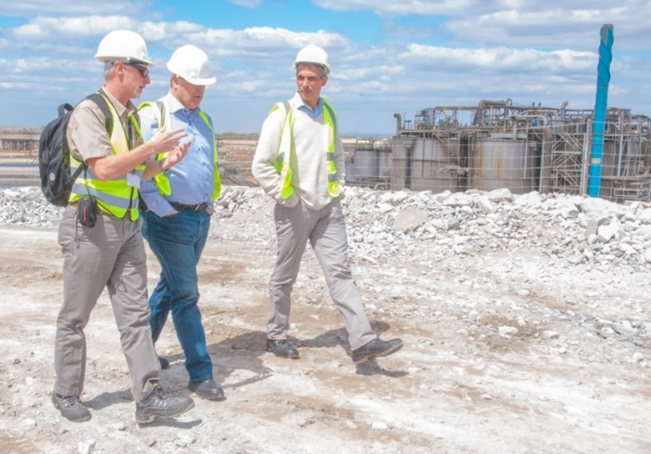

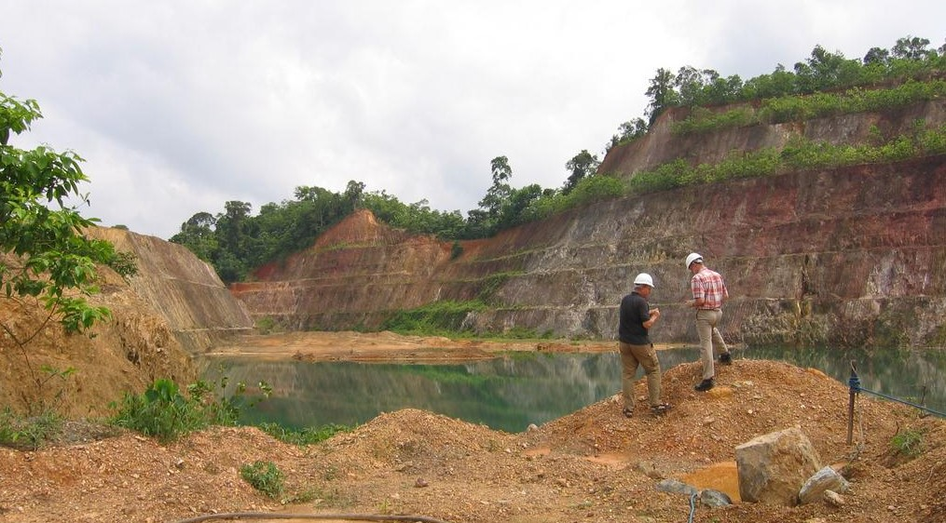

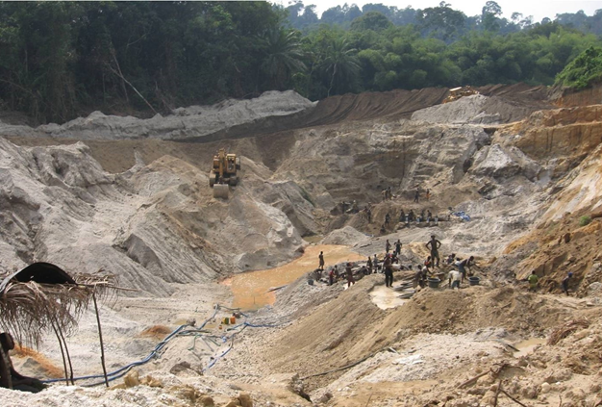

Contact:
ron@ronsmit.com
+31 624496555 (The Netherlands)
+260 966968276 (Zambia)
rpsmit (Skype)

Website:
www.ronsmit.com

Linkedin:
https://www.linkedin.com/in/ronsmit/

Twitter: https://twitter.com/ronaldpsmit

